# Chapter 5: System Requirements Specification

## Chapter Overview

Write overview please

## Stakeholder Analysis

The stakeholder analysis will be visually represented using an onion model diagram in this chapter and be further described using the roles and benefits table for each stakeholder.

### Onion Model

A diagram used to visually represent the stakeholders’ relationship among themselves and to the system proposed.

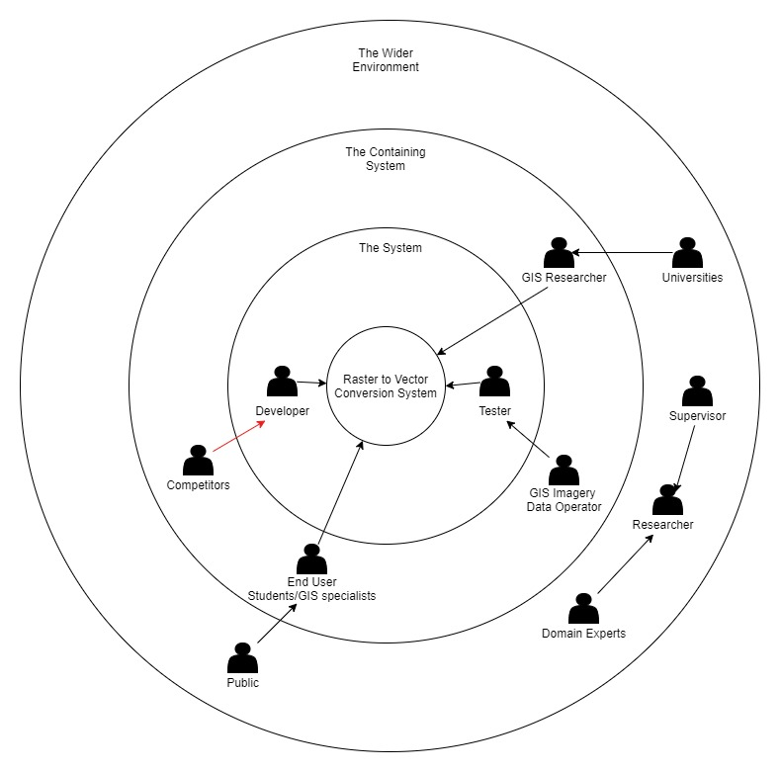

### Stakeholders and Roles

The following table describes the stakeholders and their roles and benefits to the system.

|  |  |  |
| --- | --- | --- |
| **Stakeholder** | **Roles** | **Benefits** |
| Developer | Develop System | Develops the platform with less cost |
| Tester | Test System | Test and report the accuracy of the system |
| Domain Experts | Expert on the field of study (GIS) | Provide expertise on domain related matters to make system results accurate and to evaluate them |
| Universities | Functional Beneficiary | Is allowed to convert valuable geographical data from raster formats into vector formats and other educational uses |
| GIS Researches | Is allowed to convert valuable geographical data from raster formats into vector formats |
| End User |
| Public |
| GIS Imagery Data Operator | Gather Training and Testing Data | Make system more accurate if more data sets are found for training and testing |
| Supervisor | Assist in documentation and process of building system | Improve quality of system and its documentation by giving appropriate feedback |
| Researcher | Conduct Literature reviews and research to help implement system and identify requirements | Creates valuable documentation for ease of implementation of system |
| Competitor | Negative Stakeholder | Build similar solutions with better features |

## Requirement Elicitation Process

There are multiple techniques that can be used in order to validate and verify the requirements gathered. These can be states as Questionnaires, Observations, Literature Reviews etc. This section will briefly discuss the strengths and weaknesses of each such method and justify the method(s) of approach selected for this project.

|  |  |
| --- | --- |
| **Method 1: Questionnaire** | |
| Questionnaires are carried out to gain knowledge of the developers who have a similar experience in the industry. This form is sent out to the target audience to get their feedback regarding the research. | |
| **Advantages** | * Larger research audience * Easy to analyses data obtained from questionnaire quantitatively |
| **Disadvantages** | * Feedback could contain facts that are untrue |
| **Execution:** A questionnaire is circulated among the target audience of the project which mostly comprises of developers working in the same field along with GIS Researchers who work on a daily basis with the cartographic and geographical image data that might require conversion between raster and vector. The questions were as follows.   * To identify the use of raster to vector conversion software in GIS * To identify the level of the domain where GIS uses these conversion methods * To analyze the issues faced when developing such a system * To understand the domain understanding of developers when building a similar system. | |

The information gathered from the questionnaire will be further discussed as this section continues.

|  |  |
| --- | --- |
| **Method 2: Observations** | |
| Observation of existing solutions proprietary and open source available in this domain, and to a find a unique gap that can be addressed and solved in this research. | |
| **Advantages** | * Identify short comings of current solutions |
| **Disadvantages** | * Observation varies according to observing individual |
| **Execution:** The author is reviewing existing systems and their functionalities, to identify their strength and weaknesses to address them in this research | |

|  |  |
| --- | --- |
| **Method 3: Literature Review** | |
| A widely used method in the research community when it is necessary to gain knowledge on a domain or various techniques and technologies currently being used is by conducting a Literature review on existing material. Research repositories such as IEEE, Science Direct and Google Scholar can be used for this purpose. Hence by studying this material a research gap can be identified in current system to be addressed. | |
| **Advantages** | * Identify short comings of current solutions |
| **Disadvantages** | * Observation varies according to observing individual |
| **Execution:** A literature review has been conducted using the reference of research papers and documents found from the research libraries mentioned. The literature found has been categorized as Image Processing, GI systems and Raster to Vector Conversion related topics. This section is addressed in the second chapter of this thesis document. | |

## Use Case Diagram and Description

### Use Case Diagram

The following is a diagram that represents the use cases of the system visually.

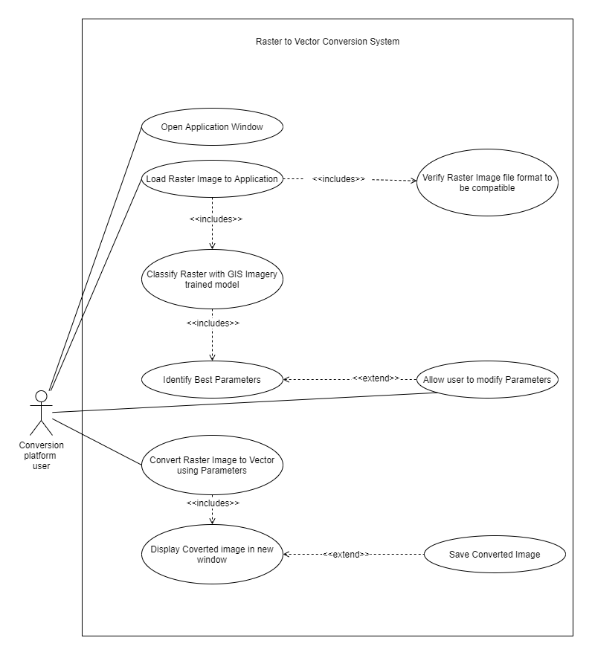

### Use Case Description

The following table will further elaborate the use cases shown in the above diagram.

|  |  |
| --- | --- |
| **Use Case ID** | **UC-1** |
| **Use Case Name** | **Open Application Window** |
| Priority | High |
| Actors | Conversion Platform User |
| Description | Open the application and initialize the system |
| Pre-condition | Application package must be downloaded and extracted onto machine running a windows OS |
| Extending Use Cases | none |
| Including Use Cases | none |
| Triggering Event | Click on Application icon from windows file explorer |
| Main Flow | 1. Open Application 2. Perform Initialization functions to prepare application |
| Alternative Flow | none |
| Exceptional Flow | none |

|  |  |
| --- | --- |
| **Use Case ID** | **UC-2** |
| **Use Case Name** | **Load Raster Image to Application** |
| Priority | High |
| Actors | Conversion Platform User |
| Description | Load a valid raster type image file onto application for processing and conversion |
| Pre-condition | Application must be opened and initialization functions should have been executed |
| Extending Use Cases | none |
| Including Use Cases | * Verify Raster Image file format to be compatible * Classify Raster with GIS imagery trained model |
| Triggering Event | Click on open file from application window |
| Main Flow | 1. Open file explorer window to browse and locate file 2. Once file is selected load file into application as an array or matrices for processing and classification |
| Alternative Flow | none |
| Exceptional Flow | none |

|  |  |
| --- | --- |
| **Use Case ID** | **UC-3** |
| **Use Case Name** | **Verify Raster Image file format to be compatible** |
| Priority | High |
| Actors |  |
| Description | Verify if the file format of the loaded file is one of the compatible file formats accepted by the system |
| Pre-condition | Application must be opened and initialization functions should have been executed and a file must be selected for the conversion process |
| Extending Use Cases | none |
| Including Use Cases | none |
| Triggering Event | Click on open file from file browser window |
| Main Flow | 1. Load file onto the application 2. Check if the file belongs to one of the valid types 3. Display file loaded successfully message |
| Alternative Flow | 3. If File is not one of the valid types show  failed to load file message |
| Exceptional Flow | none |

|  |  |
| --- | --- |
| **Use Case ID** | **UC-4** |
| **Use Case Name** | **Classify Raster with GIS imagery trained model** |
| Priority | High |
| Actors | Conversion Platform User |
| Description | Classify image with trained classification model to aid automated identification of best fit conversion parameters for that particular loaded image |
| Pre-condition | Image must be loaded onto the application and be of a valid file format type |
| Extending Use Cases | none |
| Including Use Cases | Identify Best Parameters |
| Triggering Event | Click on Analyze button on application |
| Main Flow | 1. Run classification model and classify image 2. Return classification accuracy data to find best match of GIS image classification |
| Alternative Flow | none |
| Exceptional Flow | none |

|  |  |
| --- | --- |
| **Use Case ID** | **UC-5** |
| **Use Case Name** | **Identify Best Parameters** |
| Priority | High |
| Actors | Conversion Platform User |
| Description | Use classification data to identify best fit conversion parameters for the image that was loaded |
| Pre-condition | Image classification must be performed on the loaded image |
| Extending Use Cases | Allow user to modify parameters |
| Including Use Cases | None |
| Triggering Event | System triggered after classification of image |
| Main Flow | 1. Use parameter and classification data to identify best parameters for analyzed image 2. Return parameters for the conversion 3. Display parameters and allow editing to the user |
| Alternative Flow | none |
| Exceptional Flow | none |

|  |  |
| --- | --- |
| **Use Case ID** | **UC-6** |
| **Use Case Name** | **Convert Raster image to vector using parameters** |
| Priority | High |
| Actors | Conversion Platform User |
| Description | Convert Image using raster to vector conversion library using the parameters defined |
| Pre-condition | Conversion parameters for the particular image must be set |
| Extending Use Cases | none |
| Including Use Cases | Display converted image in new window |
| Triggering Event | Click on convert button on application |
| Main Flow | 1. Initialize conversion package 2. Convert image using parameters set 3. Display success message for conversion |
| Alternative Flow | none |
| Exceptional Flow | 3. If image conversion fails, due to not  enough memory, catch exception and  handle crashes that might occur |

|  |  |
| --- | --- |
| **Use Case ID** | **UC-7** |
| **Use Case Name** | **Allow User to Modify Parameters** |
| Priority | High |
| Actors | Conversion Platform User |
| Description | Allow the user to adjust parameters obtained for best conversion within a certain range at the users own discretion |
| Pre-condition | Conversion parameters for the particular image must be set |
| Extending Use Cases | none |
| Including Use Cases | none |
| Triggering Event | Edit parameter button clicked |
| Main Flow | 1. Display editable fields for user to change parameters found before conversion 2. Edit parameters 3. Save new edited parameters |

|  |  |
| --- | --- |
| **Use Case ID** | **UC-8** |
| **Use Case Name** | **Display Converted Image in new Window** |
| Priority | High |
| Actors | Conversion Platform User |
| Description | Show preview of converted image to user |
| Pre-condition | Image conversion must be executed |
| Extending Use Cases | Save Converted Image |
| Including Use Cases | none |
| Triggering Event | System triggered after image conversion |
| Main Flow | 1. Open new preview window 2. Show converted image in window |
| Alternative Flow | none |
| Exceptional Flow | none |

|  |  |
| --- | --- |
| **Use Case ID** | **UC-8** |
| **Use Case Name** | **Display Converted Image in new Window** |
| Priority | High |
| Actors | Conversion Platform User |
| Description | Save converted image |
| Pre-condition | Preview window of converted image must be open |
| Extending Use Cases | none |
| Including Use Cases | none |
| Triggering Event | System triggered after image conversion |
| Main Flow | 1. Open file explorer window 2. Select save location 3. Press save button |

## Functional and Non Functional Requirements

### Functional Requirements

|  |  |  |  |  |  |  |
| --- | --- | --- | --- | --- | --- | --- |
| **FR No.** | **Requirement** | **Inputs** | **Process** | **Outputs** | **Priority** | **Use case** |
| **1** | Convert Image from Raster to vector | Raster Image | Convert Raster to vector from identified parameters | Vector Image | Critical | UC-6 |
| **2** | Classify GIS image with trained model | Raster Image | Use image classification model trained to identify types of GIS imagery and classify image | Image  classification score | Critical | UC-4 |
| **3** | Identify conversion parameters | Classification score | Use classification score to find best fit conversion parameters | Best fit parameters | Critical | UC-5 |
| **4** | Review output vector image |  |  | Vector Image | Critical | Do tom. |
| **5** | Change auto selected parameters and redo conversion process |  | Convert Raster to vector from manual parameters |  | Critical | Do tom |
| **6** | Save converted file to local or cloud storage |  | Save file to storage |  | Important | Do tom |

Table 6‑1 Functional Requirements

### Non-functional Requirements

|  |  |  |  |
| --- | --- | --- | --- |
| **#** | **Requirement title and description** | **Specification** | **Priority** |
| 1 | Give user proper feedback on conversion process as it can be a long and time consuming process depending on the raster image and conversion parameters | Usability | Desirable |
| 2 | Result image should be visually similar and accurate to input raster image | Accuracy | Important |
| 3 | Develop API to allow conversions using online platforms | Usability | Desirable |

Table 6‑2 Non Functional Requirements

## Chapter Summary

As chapter summary, first the stakeholders were identified and their roles were defined. After defining the roles, the requirement elicitation was carried out mainly with a questionnaire and a literature review. The outcomes of the questionnaire were discussed above with the statistics. Then the use case diagram of the system with the use case descriptions were discussed. After the use case diagram, the functional and non-functional requirements were identified.